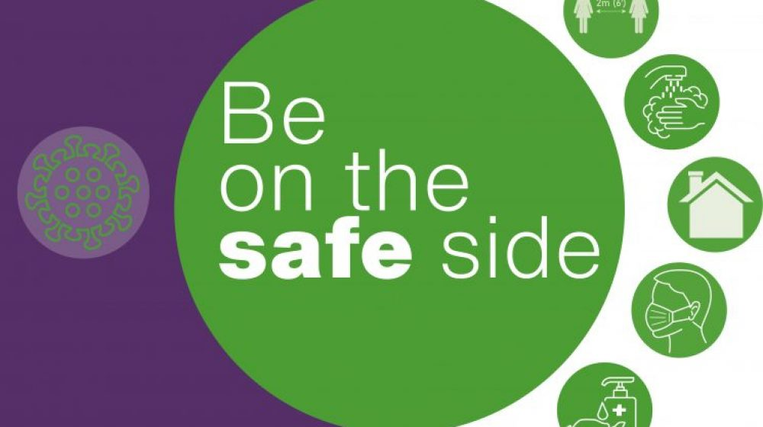

Pregnancy can be an exciting time, but it can come with its fair share of worries and anxieties – probably never more so than whilst living through a global pandemic.
The NHS has issued guidance for women during pregnancy about the risks and the healthcare they can expect to receive which might be helpful.

But what about work?
What are the risks at work? What do you need to do to advise your employer of your pregnancy?
We’re here to help and make sure you have all the information you need to speak to your employer about your pregnancy during Covid.

When should I inform my employer I am pregnant?
Once you know you are pregnant, you need to decide when to inform your employer of your pregnancy. A lot of people wait until they have had their 12-week scan to advise their employer of their pregnancy.
If you work in a hazardous workplace it is best to advise your employer as soon as possible. High risk includes things like contact with chemicals or X-rays, or a hazardous physical setting such as working from height. It is important to tell your employer early so they can make arrangements to protect you and your baby from any of those hazards.
If you are experiencing difficult pregnancy symptoms that make you too unwell to work, you should also think about telling your employer so they can accommodate you.

You may also to consider telling your employer earlier than your 12-week scan if you work in an environment where you could be exposed to COVID19. This is particularly important if you have another underlying health condition. The clinical advice from the Royal College of Obstetricians and Gynaecologists is that social distancing is particularly important for those at 28 weeks and later.
If you have other medical conditions in addition to your pregnancy, your employer needs to consider these on an individual basis.

What can I expect from my employer?
Your employer has a legal duty to assess workplace risks which must specifically include the risks to pregnant women at any stage of their pregnancy. They must take reasonable steps to remove these risks which might include:
- Looking to provide reasonable alternative work for you on the same terms and conditions (ie on your normal rate of pay);
- Changing your place, conditions or hours of work (this could include allowing you to work from home if possible);
- Suspending you on full pay if there are no other suitable alternatives.

What if I have concerns?
If you are concerned about health and safety at work at all in relation to your pregnancy it is important to raise these concerns with your employer. It’s best to do it in writing (an email will be fine). If your employer refuses to carry out a risk assessment for you, you need to get in touch with us ASAP.
Our health and safety reps are trained to support members at work when they have a concern. If you have any concerns about your health and safety during your pregnancy (COVID-related or not) please speak with your local UNISON H&S rep.
If you don’t know who that is, please contact us so we can put you in touch with the right person to support you.

